Instructions to prepare the Paper for the 3rd Iranian conference of green mining and mine industries (Times New Roman, Bold, 14 pt)
Author’s Name, 1st Author’s Name, 2nd Author’s Name, Third Author’s Name (Times New Roman, Bold, 10pt)
Author's affiliation and Email address (Times New Roman, 10 pt)
Author's affiliation and Email address (Times New Roman, 10 pt)
Author's affiliation and Email address (Times New Roman, 10 pt)
Abstract
Basic guidelines for the preparation of a technical work for the 3rd Iranian conference of green mining and mine industries are presented. This document is itself an example of the desired layout (inclusive of this abstract) and can be used as a template. The document contains information regarding desktop publishing format, type sizes, and typefaces. Style rules are provided, which explain how to handle equations, units, figures, tables, abbreviations, and acronyms. Sections are also devoted to the preparation of acknowledgments, appendices and references. The abstract is limited to 250 words in one paragraph, and cannot contain equations, figures, tables, or references. It should concisely state what was done, how it was done, principal results, and their significance. Each paper shall not exceed 8 pages. Moreover, each paper should be submitted with one extended abstract formatted according to the sample document provided separately, to appear in printed proceeding.
Keywords: The author shall provide up to 5 keywords to help identify the major topics of the paper.

- Introduction
This document provides an example of the desired layout for the 3rd Iranian conference of green mining and mine industries papers and can be used as a template for Microsoft Word versions 97 and later. It contains information regarding desktop publishing format, type sizes, and typefaces. Style rules are provided to explain how to handle equations, units, figures, tables, abbreviations, and acronyms. Sections are also devoted to the preparation of appendixes, acknowledgments, references, and authors’ biographies.
- Technical Work Preparation
Please use automatic hyphenation and check your spelling. Additionally, be sure your sentences are complete and that there is continuity within your paragraphs. Check the numbering of your graphics and make sure that all appropriate references are included.
  - Template
This document may be used as a template for preparing your technical work. When you open the file, select "Print Layout" from the "View" menu (View | Print Layout), which allows you to see the footnotes. You may then type over sections of the document, cut and paste into it (Edit | Paste Special | Unformatted Text), and/or use markup styles. The pull-down style menu is at the left of the Formatting Toolbar at the top of your Word window (for example, the style at this point in the document is "Text"). Highlight a section that you want to designate with a certain style, then select the appropriate name on the style menu.
  - Format
If you choose not to use this document as a template, prepare your technical work in single-spaced, single-column format, on A4 paper. Set top and bottom margins to 20 millimeters and left and right margins also to 20 millimeters. Do not violate margins (i.e., text, tables, figures, and equations may not extend into the margins). Use full justification.
  - Typefaces and Sizes
Please use a proportional serif typeface such as Times Roman or Times New Roman and embed all fonts. Table 1 provides samples of the appropriate type sizes and styles to use.
Table 1: Samples of Times Roman Type Sizes and Styles Used for Formatting a PES Technical Work
Point  Size | Purpose in Paper | Special  Appearance
9 | Table text, Figure text | Table text
9 | figure and table captions | Figure caption
10 | Body text, | Main text
10 | Author’s Affiliation  Equations, | Subheadings
10 | Author's Name, Second Heading | Section Titles
11 | Main Heading | Heading 1
14 | Paper Title | Title

- Section Headings
A primary section heading number is followed by a period and is centered above the text. A primary heading should be in capital letters.
A secondary section heading number is followed by a period and is flush left above the section. The first letter of each important word is capitalized and the heading is italicized.
A tertiary section heading is enumerated by an Arabic numeral followed by a parenthesis. It is indented and is followed by a colon. The first letter of each important word is capitalized and the heading is italicized.
A quaternary section heading is rarely necessary, but is acceptable if required. It is enumerated by a lowercase letter followed by a parenthesis. It is indented and is followed by a colon. Only the first letter of the heading is capitalized and the heading is italicized.
  - Figures and Tables
Figure axis labels are often a source of confusion. Try to use words rather than symbols. As an example, write the quantity "Magnetization," or "Magnetization, M," not just "M." Put units in parentheses. Do not label axes only with units. As in Figure 1, write "Magnetization (kA/m)" or "Magnetization (kA·m⁻¹)," not just "kA/m." Do not label axes with a ratio of quantities and units. For example, write "Temperature (K)," not "Temperature/K." Figure labels should be legible, approximately 8- to 10-point type.
Large figures and tables may not extend into the page margins. Figure captions should be below the figures; table captions should be above the tables. Do not put captions in "text boxes" linked to the figures. Do not put borders around your figures. Use Insert | Reference | Caption to number your tables and figures, and use Insert | Reference | Cross- reference to refer to their numbers.
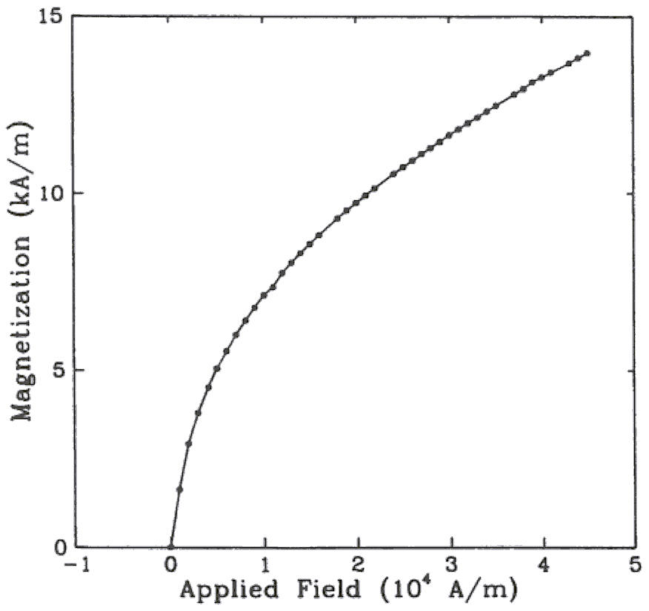

Figure 1: Magnetization as a function of applied field. (Note that there is a colon after the figure number followed by two spaces.)
All figures and tables must appear near, but not before, their first mention in the text. Use the abbreviation "Fig. 1," even at the beginning of a sentence. To insert images in Word, use Insert | Picture | From File.
  - Numbering
Number reference citations consecutively in square brackets [1]. The sentence punctuation follows the brackets [2]. Multiple references [2], [3] are each numbered with separate brackets [1]-[3]. Refer simply to the reference number, as in [3]. Do not use "Ref. [3]" or "reference [3]" except at the beginning of a sentence: "Reference [3] shows…."
Number footnotes separately with superscripts (Insert | Footnote). Place the actual footnote at the bottom of the column in which it is cited. Do not put footnotes in the reference list. Use letters for table footnotes.
Appendix figures and tables should be numbered consecutively with the figures and tables appearing in the rest of the paper. They should not have their own numbering system.
- Units
Metric units are preferred for use and the use of the International System of Units is advocated. This system includes a subsystem of units based on the meter, kilogram, second, and ampere (MKSA).
- Abbreviations and Acronyms
Define less common abbreviations and acronyms the first time they are used in the text, even after they have been defined in the abstract. Abbreviations such as IEEE, SI, MKS, CGS, ac, dc, and rms do not have to be defined. Do not use abbreviations in the title unless they are unavoidable.
- Math and Equations
Number equations consecutively with equation numbers in parentheses flush with the right margin, as in (1). First use the equation editor to create the equation. Then select the “Equation” markup style. Write the equation number in parentheses using Insert | Caption.
Use the Microsoft Equation Editor for all math objects in your paper (Insert | Object | Create New | Microsoft Equation or Math Type Equation). "Float over text" should not be selected.
To make your equations more compact, you may use the slash ( / ), the exp function, or appropriate exponents. Italicize Roman symbols for quantities and variables, but not Greek symbols. Use a long dash rather than a hyphen for a minus sign. Use parentheses to avoid ambiguities in denominators. Punctuate equations when they are part of a sentence, as in
().
Number equations consecutively with equation numbers in parentheses flush with the right margin, as in (1). Be sure that the symbols in your equation have been defined before the equation appears or immediately following. Italicize symbols (T might refer to temperature, but T is the unit Tesla). Use Insert | Reference | Caption to number equations. Refer to “(1),” not “Eq. (1)” or “equation (1),” except at the beginning of a sentence: “Equation (1) is ...”. Use two column tables to locate equations and their numbers properly in one line, as follows:
()
Where I_{F} is the fault current. Be sure that the border is off.
- Appendix
Appendixes, if needed, appear before the acknowledgment. Subsections for this part also should be numbered by alphabets.
- Nomenclature
A nomenclature list, if needed, should precede the Appendixes.
- Acknowledgment
The following is an example of an acknowledgment:
The author gratefully acknowledges the Iranian Tunnelling Association for their work on the original version of this document.

References
References are important to the reader; therefore, each citation must be complete and correct. There is no editorial check on references; therefore, an incomplete or wrong reference will be published unless caught by a reviewer or discusser and will detract from the authority and value of the paper. References should be readily available publications.
List only one reference per reference number. If a reference is available from two sources, each should be listed as a separate reference. Give all authors' names; do not use et al.
Samples of the correct formats for various types of references are given below.

Periodicals and journal papers:
Fuller, J.F.,Fuchs,E.F. and K. J. Roesler, "Influence of harmonics on power distribution system protection",IEEE Trans. Power Delivery, vol. 3, pp. 549-557, Apr. 1988.
R.J. Vidmar. (1992, Aug.).On the use of atmospheric plasmas as electromagnetic reflectors.IEEE Trans. Plasma Sci. [Online].21(3), pp. 876-880. Available: http://www.halcyon.com/pub/journals/21ps03-vidmar

Books:
E. Clarke, Circuit Analysis of AC Power Systems, vol. I. New York: Wiley, 1950, p. 81.

Technical Reports:
Reber, E.E.,Mitchell,R.L. and C.J. Carter, "Oxygen absorption in the Earth's atmosphere," Aerospace Corp., Los Angeles, CA, Tech. Rep. TR-0200 (4230-46)-3, Nov. 1968.
S.L. Talleen. (1996, Apr.). The Intranet Architecture: Managing information in the new paradigm. Amdahl Corp., Sunnyvale, CA. [Online]. Available: http://www.amdahl.com/doc/products/bsg/intra/ infra/html

Papers Presented at Conferences (Unpublished):
Ebehard,D. and E. Voges, "Digital single sideband detection for interferometric sensors," presented at the 2nd Int. Conf. Optical Fiber Sensors, Stuttgart, Germany, 1984.
Process Corp., Framingham, MA. Intranets: Internet technologies deployed behind the firewall for corporate productivity. Presented at INET96 Annu.Meeting.[Online]. Available: http://home.process.com/ Intranets/wp2.htp

Papers from Conference Proceedings (Published):
AlqueresJ.L. and J.C. Praca, "The Brazilian power system and the challenge of the Amazon transmission," in Proc. 1991 IEEE Power Engineering Society Transmission and Distribution Conf., pp. 315-320.

Dissertations:
S. Hwang, "Frequency domain system identification of helicopter rotor dynamics incorporating models with time periodic coefficients," Ph.D. dissertation, Dept. Aerosp. Eng., Univ. Maryland, College Park, 1997.

